Fylde Folk

Catholic Folk of Preston and the Fylde

An introduction to their history and genealogy
"Lancashire seems to be the great centre of Catholicism in Lancashire and Preston appears to be its centre in Lancashire"
A.Hewitson, known as "Atticus" wrote a number of "sketches" on churches of Preston in the Preston Chronicle in 1869 on "Our Churches and Chapels, their Parsons, Priests and Congregations". He began:  It is important that something should be known about our churches and chapels; it is more important that we should be acquainted with their parsons and priests; it is most important that we should have a correct idea of their congregations, for they show the consequences of each, and reflect the character and influence of all...  Of particular importance in considering the story of Catholic congregations is what Hewitson had to say when writing about St Wilfred's:  It was at one time of the day a rather dangerous sort of thing for a man, or a woman, or a medium-sized infant, living in this highly-favoured land of ours, to show any special liking for Roman Catholicism. But the days of religious bruising have perished; and Catholics are now, in the main, considered to be human as well as other people, and to have a right to live, and put their Sunday clothes on, and go to their own places of worship like the rest of mortals... | 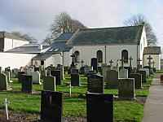  Children from the mission at  St Andrew's, Cottam  were confirmed on the  8th of September 1813 at  Our Lady of the Well,  Fernyhalgh
Fulwood, north of Preston and also on the southern edge of the Fylde belongs in many ways, not least in the history of its people, to both areas. 'Fylde' is an old word for 'field', simply referring to the low pastoral land north of the R.Ribble between the hills and the sea. The area north of the R.Wyre to Lancaster and the R.Lune, is sometimes called 'North Fylde' and is included here as the division is otherwise rather artificial. The whole area has been known since the time of the Norman Conquest as 'Amounderness'.  Some of the children referred to - see right - came from Fulwood  which is between Cottam and Fernyhalgh.See List of names on the Cottam page | 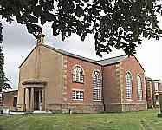
The word 'parish' is used above in the modern sense. From now on the various churches, chapels and houses will be referred to more correctly as 'missions' before the Restoration of the English Hierarchy in 1851. The word 'parish' refers in historical records to the ancient parish which became Anglican at the Reformation.
The older Fylde chapels were sometimes old barns, or were built to resemble them, partly to avoid the kind of trouble which sometimes erupted, as when a mob, whipped up by the frenzy of the Gordon riots in London, marched out from Preston intent on destroying St Andrew's.
The old and the new stand side by side at Poulton-le-Fylde.
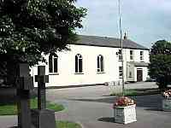 | Catholics were not allowed churches during penal times and had to worship in secret. Later, when they built chapels it was forbidden to add towers or spires or any other markings, such as a cross, to make them look like churches. After a turbulent history beginning in Singleton not long after the Reformation, the mission at Poulton used the building on the left, erected about 1813. The church on the right replaced it about 1912. | 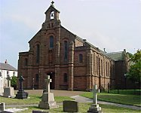
The Fylde and Amounderness
Fylde is simply an old name for the Field, meaning usually the lowlands bounded from north to south by the rivers Ribble and Wyre and east to west by the hills and the sea. Unfortunately it is frequently misunderstood and even transcribed as 'Flyde'. Occasionally it also included the area between Lancaster and the sea north of the R.Wyre, though since the creation of the 'Fylde Borough Council' this rarely happens now. It would probably be better to refer to the whole area by its old name of 'Amounderness' which dates from the opportionment of land to the barons in the time of William the Conqueror. Some of the chapels in this northern area which reaches into the valley of the Lune are still of interest genealogically so have been added here
Abbreviations:
CRS=Catholic Record Society (with Vol. no.)
CRO=County Record Office (i.e.Lancs)
Dom.Ch.=Domestic Chapel
Conf.=confirmations These 1687 records are in Westminster Diocesan Archives.
c.=century
IGI=International Genealogical Index, compiled by the LDS church; batch nos. provide useful shortcuts; (a finding aid, not a primary source!)
LDS= Latter Day Saints (more familiarly known as Mormons)
Numbers were used to collect records, transcribed mainly from church registers before 1837, in batches. The films are compiled from submissions, claimed to be from LDS members (but not necessarily). On the IGI Family Search page you can enter just the surname you are researching, "Great Britain" and the batch or film no. in the appropriate box to get a list of people with that name.
M=marriages, C=christenings but letters J, E, P and K are among others used. These will be included on the appropriate pages.
The area covered at present is the group of chapels serving Fulwood and Broughton,There were considerable overlaps between missions. Families attended, as they still do, a parish of their choice, so when searching for records it is important to look at all the surrounding missions and of course also the parish churches, so some of those listed here have links to the Churches Together pages elsewhere on this site. (The areas served by the parish churches were quite different from those served by the missions).
Catholic Chapels
St Andrew's, Cottam | St Mary's, Newhouse | St Mary's, Fernyhalgh
 | 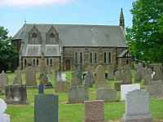
Woodplumpton, Catforth, Eaves, Fulwood, Ingol, | (aka Newsham)  Woodplumpton, Broughton, Barton, Myerscough | Fernyhalgh, Fulwood, Haighton

Parish Churches
St Anne's, Woodplumpton | St John the Baptist, Broughton | (later) Christchurch | St Lawrence, Barton
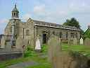 | 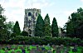 | 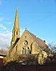 | photo to come
All records are frequently incomplete. Although a mission may date from an earlier century only the exact year given has the earliest known record. Originals are usually in the CRO, but many records have gaps and not all missions recorded marriages or burials. Very full details of what is available can be found in Michael Gandy's Catholic Missions and Registers 1700-1880, Vol.5 North-West England, obtainable through the Family Tree magazine or available in some libraries and/or record offices.

